1. **$git reset HEAD^1:** command moves the current branch backward by two commits, effectively removing the two snapshots we just created from the project history.

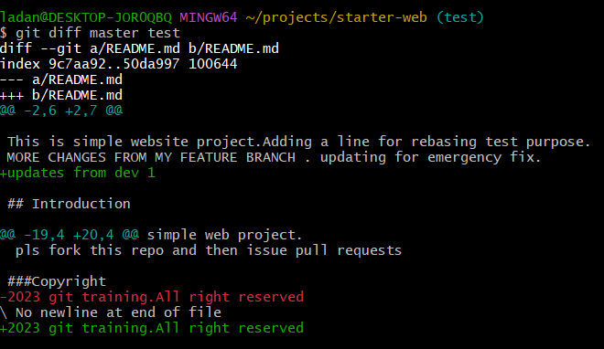

**$git reflog:** Git uses the git reflog tool to keep track of changes made to branch tips. It lets you go back to any commit, even if it isn't referenced by any branch or tag. Following the rewriting of history, the reflog contains information about the former state of branches and allows for reverting to that state if necessary.

1. **$git fetch origin branchname:** It will fetch the branch that are remotely changed or added.

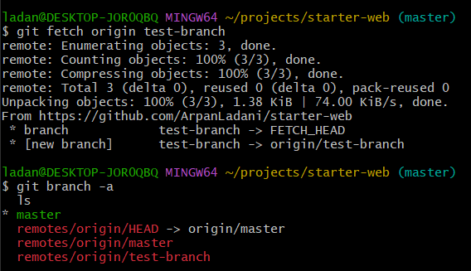

* Just create test branch in origin/test-branch

**$git branch test origin/test-branch**

* Get into that branch and pull if not up to date.

**$git checkout test, $git pull**

* Now compare test branch and master branch.

**$git diff master test**

